

Appointment application

**Section ZAO | Team #2**

Team Members:

|  |  |  |
| --- | --- | --- |
| **M** | **ID #** | **Name1** |
| **1** | 1845262 | Majed Abdullah AlGhamdi |
| **2** | 1845119 | Abdullah AlOrfi |
| **3** | 1846160 | Abdulmajeed Mohammed Gamlo |
| **4** | 1846426 | Taher Mohammed Zabidi |

Instructor: Dr. Mohammed Atif



# **Table of Contents**

**Table of Contents** 1

**Summary** 2

**Introduction** 2

**Tutorial** 3

**Screenshots of App** 3

**Disscusion** 5

**Conclusion** 5

**Summary**

The project was made in hopes to help patients that do not want to wait or unable to wait and gives them the liberty to easily book an appointment at the hospital in a matter of seconds and without waiting. This can also help with people that have social anxiety and have a hard time talking with other people.

**Introduction**

Calling to make an appointment at general hospitals can take a lot of time. Many patients are tired of waiting for their call to be answered. Moreover, they sometimes do not have the ability to wait in the line, so we worked on an application with a straightforward layout that enables patients to book an appointment in a matter of seconds and it is available 24/7, allowing them to skip the waiting time on call lines or the need to go to the hospital to book an appointment. It also, allows the patient to describe the problem briefly to give the doctor some context about their problem and which doctor the appointment is directed to. In this report, we will explain how the application works, step by step, displaying the functions and how to operate the application. Then, we will discuss how the application may branch out to other facilities and how it can hopefully help eliminate waiting for everything.

**Program Tutorial**

**Step1:**

**Step2:**

**Step3:**

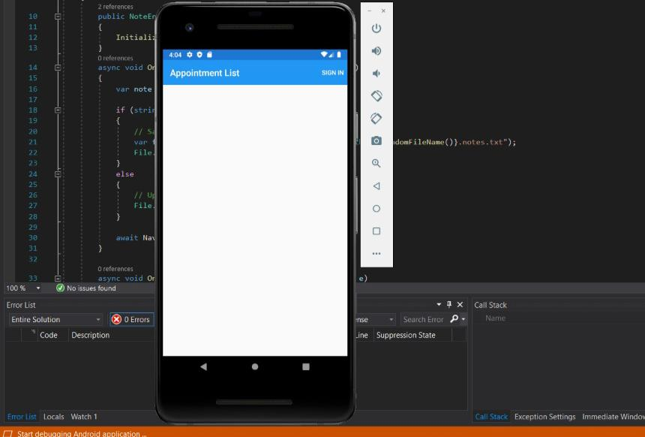

Step4

**Step4:**  We press sign in to go to the next page.

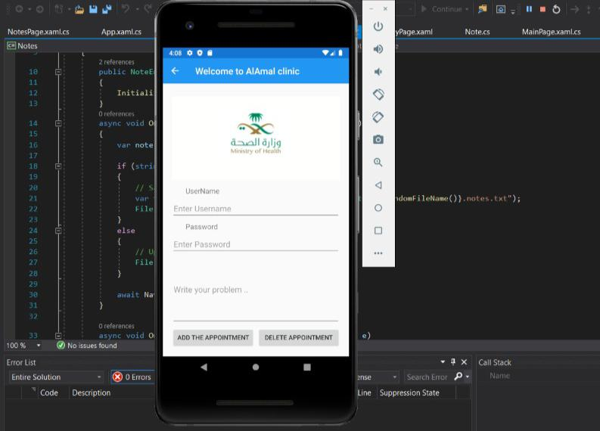

Step5

**Step5:** This is the signup interface of the program we enter the name and password and the problem that we having, then we click on ADD THE APOINTMENT.

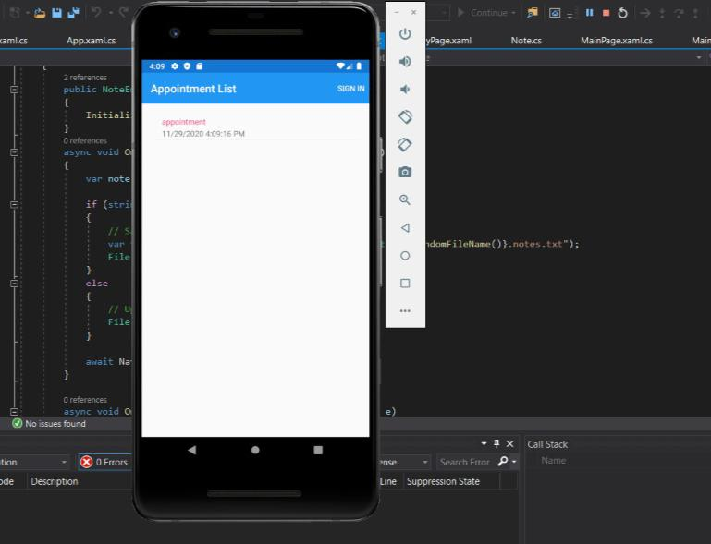

Step6

**Step6:** Here all the appointments that we sign will show up.

**Conclusion**

At the end of this report, we started with a summary illustrating the idea of the program then we explained in the program tutorial in details how the application works step by step with the provided pictures and screenshots. Briefly, our project is an appointment application that help patients that don’t like to wait long hours and provide them the liberty to book an appointment at the hospital in a few seconds without having to wait a minute. It is also helpful for people that have anxiety and have a hard time talking with others. So, we can say that it organizes and saves time and effort for the patients, and finally it is easy to use as we showed in detail.

**Appendix:**



